Program

Opening
Mr. Jay Somerville, President Ohio Chapter of APCO,
Technical Services Bureau Commander,
City of Dublin Police Communications

Honor America
National Anthem – Mr. Mel Meloy, Fairfield County Sheriff’s Office

Introduction of Keynote Speaker
Mr. William Hinkle, Director, Hamilton County Communications Center

Keynote Speaker
State Representative Larry L. Flowers, Franklin County

Invocation

Dublin Police Chaplain Steve Norden
New Hope Church in Powell, Ohio

Lunch

Sponsor Recognition
Mr. Greg Wenz, Chair - Ohio Gold Star Awards Program,
Operation Director—Hamilton County Communications Center

Award Presentations—
Mr. Jay Somerville, Emcee
Awards:
Gold Star Certificates
Double Gold Awards - Dispatch Teams
Solid Gold Awards
2005 Ohio Telecommunicator of the Year Award

Benediction
Chaplain Steve Norden
Closing
“God Bless America” Mr. Mel Meloy, Communications Supervisor Fairfield County Sheriff’s Office

Seated at the Head Table: Chaplin Steve Norden, Kim Brandt, Jay Somerville, Representative Larry Flowers, William Hinkle, Greg Wenz

We welcome you to the 2005 Gold Star Awards Program. It is with great pleasure that the Ohio Chapters of APCO and NENA welcome the recipients of the Gold Star Awards and their guests. We are extremely proud of each nominee and the work they do every single day. Making a selection of this type is very difficult since all the telecommunicators in the State do an outstanding job. Every telecommunicator has handled calls during the year that would be award winning. Additionally, the service they provide to the public on a daily basis makes everyone in the State of Ohio a winner.
We extend special thanks to the 2005 Gold Star Awards Committee who has worked hard to prepare for today’s event. They have devoted much time and energy to make this special recognition a success. We thank the supervisors and administrators for all the superb nominations that they offered.
We also want to acknowledge the corporate sponsors for their generous financial support of the Gold Star Program, as well as for their continuous support for NENA and APCO.
To all the nominees, on behalf of NENA and APCO, we offer our sincere congratulations, appreciation, and thanks for jobs well done.

Sincerely,
Jay Somerville Monte Diegel
Jay Somerville Monte Diegel
President, President,
Ohio Chapter APCO Ohio Chapter NENA

Ohio NENA Board

President
Monte Diegel, Mercer County Sheriff’s Office Central Dispatch

Vice President
Kim Brandt, Van Wert County 9-1-1

Secretary
Rose Chambers, Wood County Sheriff’s Office

Treasurer
Valerie DeRose, Summit County Emergency Management

Ohio Chapter of APCO, Executive Board

President
Jay Somerville, Dublin Division of Police

1st Vice President
Holly E. Wayt, City of Westerville Communications

2nd Vice President
Matt Franke, City of Oxford Police

Secretary/Treasurer
Danielle J. Klavinger, Lucas County Emergency Services

Executive Council Representative
Lynne Feller, Wayne County Justice Center

The Gold Star Awards committee would like to thank the following
people for their support and participation in the program.
State Representative Larry Flowers
Chaplain Steve Norden
Mr. Mel Meloy
Public Safety Training Consultants

The Gold Star Selection Committee
Ms. Carol Armitage
Ms. Holly Wayt
Mr. Monte Diegle
Mr. Jay Somerville

Ohio’s Gold Star Award Program for
Telecommunicators

The Ohio Chapters of the National Emergency Number Association (NENA) and the Association of Public-Safety Communications Officials, International (APCO) have worked together to recognize the outstanding work performed by public-safety communications personnel in Ohio. Several years ago both Chapters saw a critical need for some positive recognition and acknowledgement of the fine work that is performed by these communications professionals. Our goal was to publicly express appreciation, and to recognize both outstanding individual and team performance and consistent, steadfast leadership. Both of the Chapters are proud to present The Ohio 9-1-1 Gold Star Awards program. Because Telecommunicators work in the background, behind the lights, sirens and cameras, they are sometimes forgotten. APCO and NENA have worked in concert to promote and recognize outstanding performance in the dispatch centers around Ohio. Thank you for joining us today to show your appreciation for these dedicated and hard working individuals.

The Gold Star Award Committee

2005 Gold Star Certificates

Highway Patrol Dispatcher Melissa Baldwin
Ohio State Highway Patrol – West Jefferson Post

Communications Officer Joanne Barton
Defiance County Communications Center

911 Dispatcher Dawn Burns
City of Fairfield Police Department

Dispatcher Charlotte Cooper
Delaware Police Department

Communications Technician Dawn Cunningham
Lancaster Police Department

Emergency Operator Carmen Day
City of Dayton Police Department

Dispatcher Anne Duncan
City of Mentor

Dispatcher J. Barbara Harper
City of Cleveland, Division of Police Communications

Fire and EMS Dispatcher Patricia Hemmerick
Dayton Fire Department

Highway Patrol Dispatcher Pamela Hershberger
Ohio State Highway Patrol – Marion Post

Highway Patrol Dispatcher Pamela Kelly
Ohio State Highway Patrol – Xenia Post

Dispatcher Dan Kissling
Oregon Police Department

Highway Patrol Dispatcher Rhonda Macarthy
Ohio State Highway Patrol, Berea Post

Highway Patrol Dispatcher Brent Sigler
Ohio State Highway Patrol – Bucyrus Post

2005 Double Gold Awards

Team Award Winner

Lorain County 9-1-1

9-1-1 Dispatcher Donna Chopcinski
9-1-1 Dispatcher Melody Leisure
9-1-1 Dispatcher Kurt Scholl

For outstanding performance on July 16, 2005 during severe flooding in Lorain County. Three and one half inches of rain fell in one 30 minute period, resulting in hundreds of calls for help, people trapped in vehicles and twelve feet of water covered parts of the County.

Nominees:

Cleveland Police Department, Communications

Dispatcher Diane Eck
Dispatcher Tracey Chipgus

Dublin Police Communications

Communications Technician Carolyn Fergus
Communications Technician Ben Karns

Ohio State Highway Patrol – Ravenna Post

Highway Patrol Dispatcher Heather Turner
Highway Patrol Dispatcher Blaine Decker

Ohio State Highway Patrol – Toledo Post

Highway Patrol Dispatcher Brian Gettinger
Highway Patrol Dispatcher James Barlow
Highway Patrol Dispatcher Jennifer Sabin

Ohio State Highway Patrol – Walbridge

Highway Patrol Dispatcher Barbara Welsh
Highway Patrol Dispatcher Shirley Knitz
Highway Patrol Dispatcher Cheryl Babione

Toledo Police 9-1-1

Communications Operator Moneick Alford
Communications Operator Angel Berente
Sergeant Deonn Bortel
Communications Operator Mary Lou Castilleja
Sergeant Phil Cook
Communications Operator Lucinda Craig
Communications Operator Deb Davidson
Communications Operator Teri Ellis
Communications Operator Chris Evans
Communications Operator Dawn Gaston
Communications Operator Christine Griffin
Communications Operator Eileen Herrick
Communications Operator Haylee Kaiser
Communications Operator Stephanie Lanoce
Communications Operator Tracy Lembke
Communications Operator Becki Niemiec
Communications Operator Jennifer Overcashier
Communications Operator Marsha Perry
Communications Operator Judy Plunkett
Communications Operator Dena Rieger
Communications Operator Janie Stiles
Communications Operator Diana Trevino

2005 Solid Gold Award

OHIO 2005 TELECOMMUNICATOR OF THE YEAR

Highway Patrol Dispatcher Heather Turner
Ohio State Highway Patrol – Ravenna Post

For excellence during a bizarre series of events that involved numerous shots fired at police, kidnapping, a burglary, assaults and three homicides, on January 21, 2005.

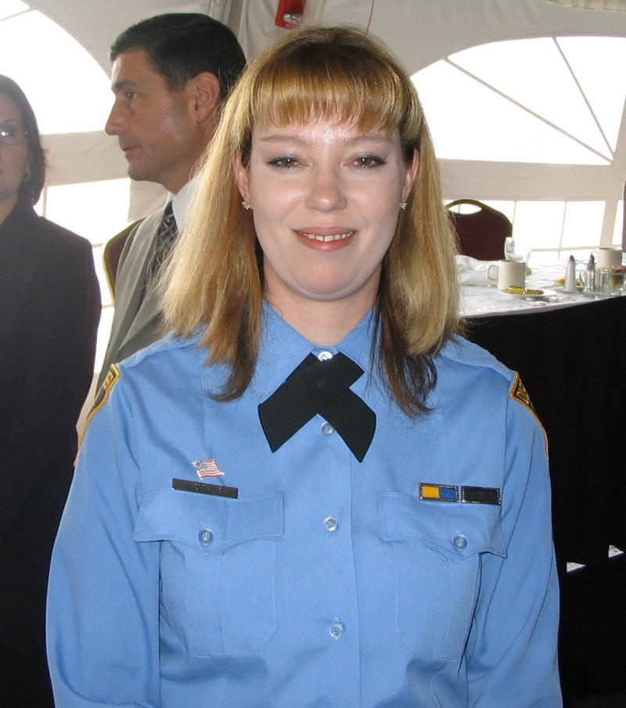

Nominees:

Dispatcher Teresa Clark
Montgomery County Sheriff’s Office

Dispatcher Kimberlee Dalton
Ontario Police Department

Toledo Police 9-1-1 Operator Teri Ellis
Toledo Police 9-1-1

Lead Dispatcher Dawn Ellis-Whittemore
Xenia/Green Central Communications Center

Dispatcher Shannon Forrider
Athens County Emergency Communications

Communications Operator Vanessa Haley
Clark County Sheriff’s Office

Highway Patrol Dispatcher Adam Quinn
Ohio State Highway Patrol – Delaware Post

Communications Deputy Wendy Ritterbach
Ottawa County Sheriff’s Office

Communications Officer Rod Smith
Van Wert County Sheriff’s Office

Dispatcher Carolyn Sowell
Joint Fire Dispatch Center

Dispatcher Rick Spoor
Van Wert Police Department

Emergency Operator Stephanie Thoma

Dispatcher Jaclyn Tryon
Ashtabula County Sheriff’s Office

Gold Star Awards Supporting Sponsors
The Gold Star Committee is extremely grateful to these companies for their sponsorship of the Ohio Gold Star Awards Program. Their generosity allows the recognition of our Ohio heroes. Thank you very much.

DDTI
Nonspecific contribution

EmergiTech
Nonspecific contribution

Intrado
Nonspecific contribution

Motorola
Nominee’s shirts

The following vendors also provided items for the nominees:

DDTI, Inc
EmergiTech
InterAct
Public Safety Training Consultants
Vonage

Today’s Lunch Includes:
Garden Salad and Rolls
Peppercorn Crusted Sirloin Medallions
Green Beans Almandine
Oven Roasted Red Skin Potatoes
New York Cheese Cake
or
Belgian Chocolate Mousse

